Scenario 1:
- Started with "Translate Single Document" from Welcome menu.
- Set Project Languages as Greek to English US.
- Added one TM (Greek to English US).
- No duplicates when making changes to saved TUs.
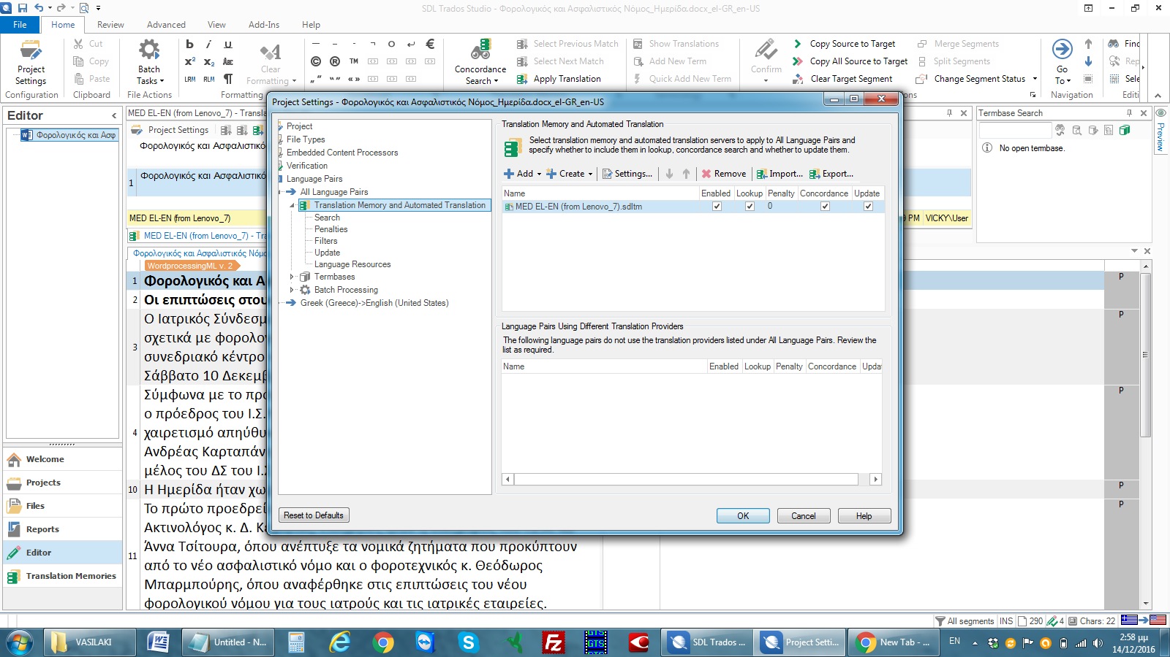

- Added a second TM (Greek to English UK), using the Any TM option.
- Again no duplicates when making changes to saved TUs.
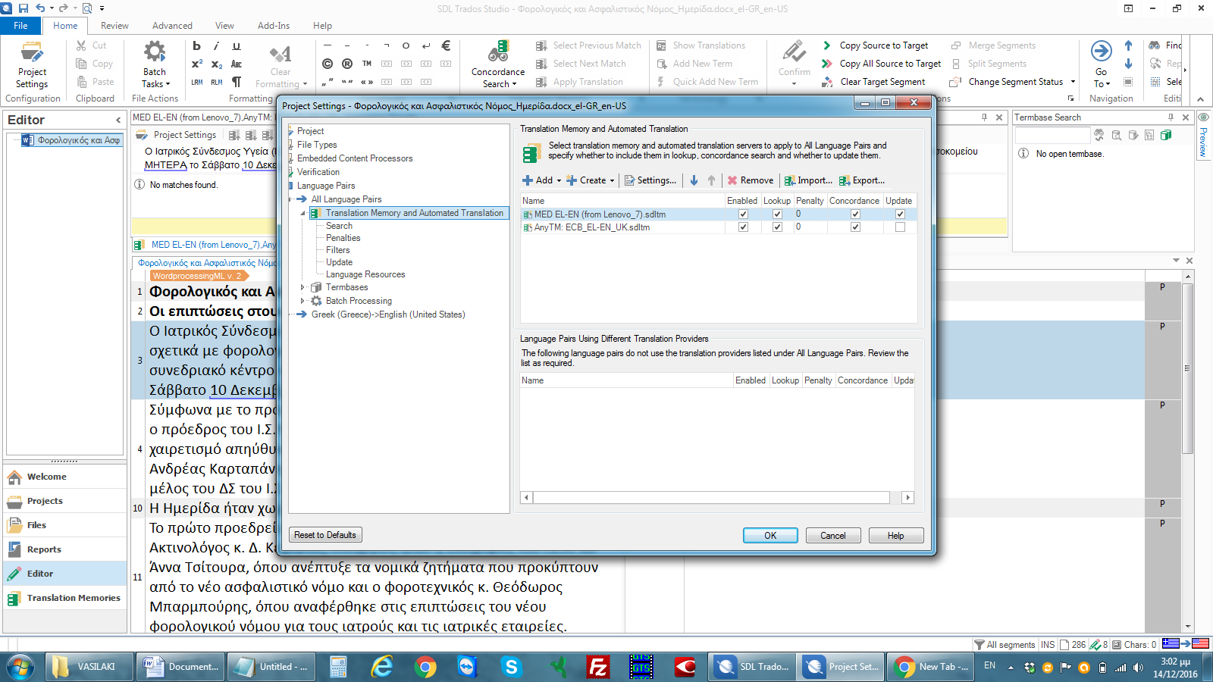
Scenario 2:
- Started with "Translate Single Document" from Welcome menu.
- Set Project Languages as Greek to English UK.
- Added one TM (Greek to English US), using the any TM option.
- Duplicates appear when making changes to saved TUs.

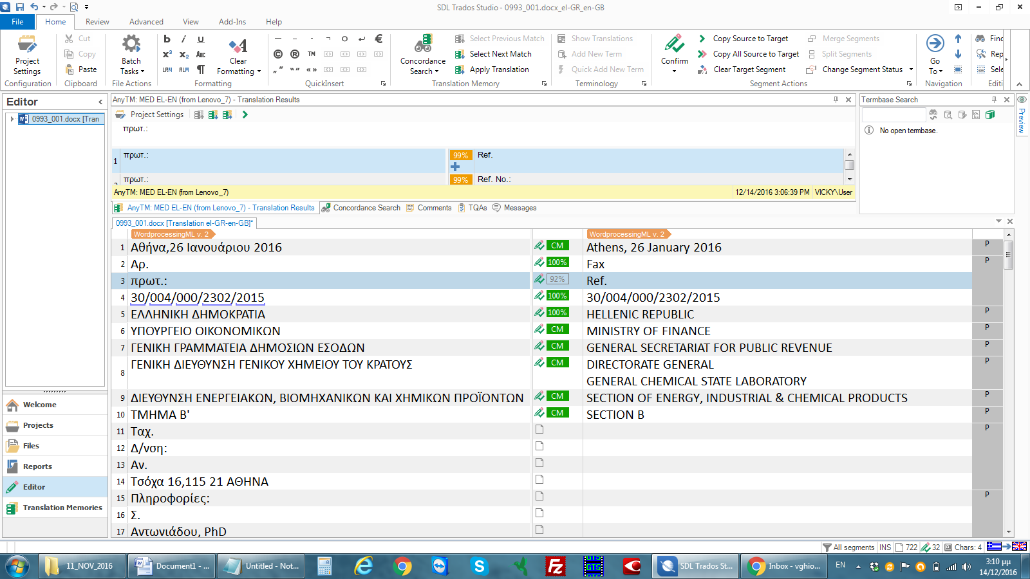

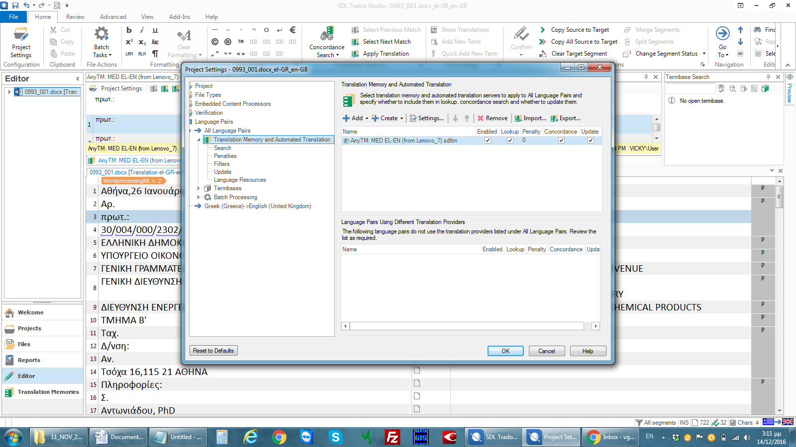

Scenario 3:
- Started with "Open Packaged" from Welcome menu (Package was sent by client, with one TM added by them and project languages set as Greek to English UK).
- No duplicates when making changes to saved TUs.
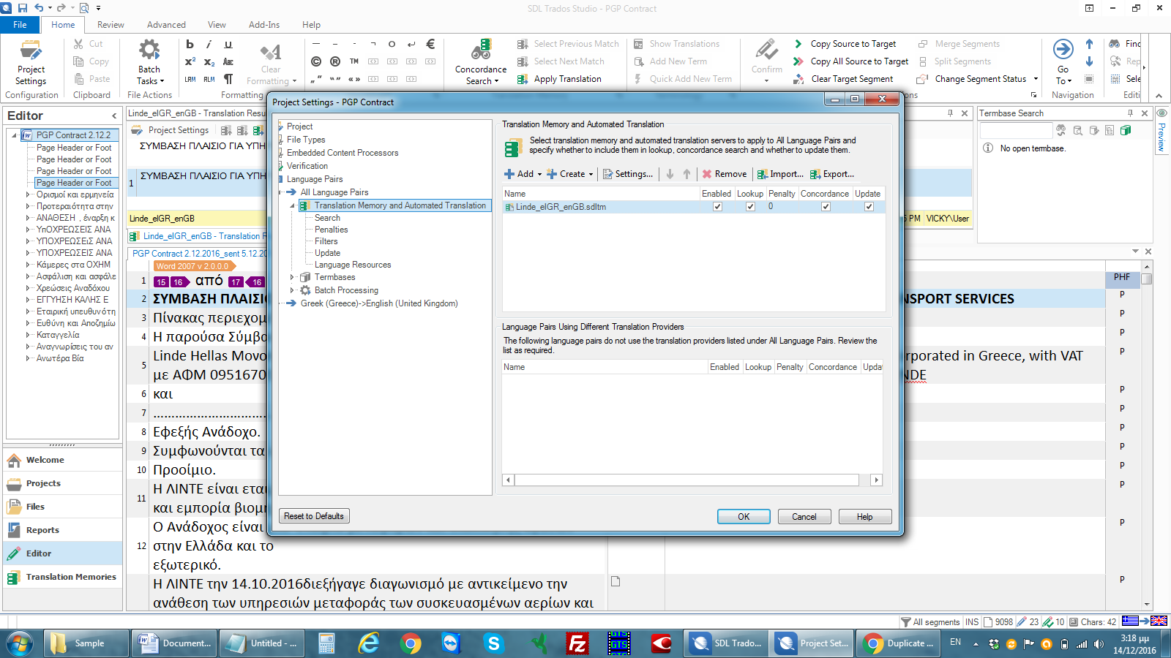

- Added a second TM (Greek to English US) using the Any TM option
- Duplicates appear when making changes to saved TUs (but only when the Update option is ticked for both TMs.




